Year 10 Genetics and Evolution test

Name _______________________________ Mark ____/51

Part A - Multi choice questions (16 marks)

 | The chemical compound that contains the coded instructions for the way that cells develop is:  - an amino acid.  - DNA.  - glucose.  - HCl. |  | 1
 | Which of the following best describes the structure of DNA proposed by Watson and Crick?  - Double helix  - X and Y shaped  - Long and twisted  - Round spheres |  | 1
 | In eukaryotes, DNA is produced in the:  - cell membrane.  - endoplasmic reticulum.  - nucleus.  - cytoplasm. |  | 1
 | When cells are about to divide, lengths of DNA shorten and coil to form:  - chromosomes.  - genes.  - messenger RNA.  - zygotes. |  | 1
 | The process of cell division that produces the gametes in the sex organs is:  - cloning.  - fertilisation.  - meiosis.  - mitosis. |  | 1
 | Human body cells normally contain 46 chromosomes. The number of chromosomes in the fertilised egg that forms a new zygote is:  - 23.  - 46.  - 92. |  | 1
 | The alternative forms of each gene are called:  - alleles.  - gametes.  - hybrids.  - monohybrids. |  | 1
 | In humans, the gene for black hair (B) is dominant over the gene for red hair (b). The genotype of a person with red hair is:  - black hair.  - brown hair.  - red hair.  - BB.  - Bb.  - bb. |  | 1
 | If a woman has already given birth to four boys, the chance that she will have a girl next time is:  - zero.  - one in five.  - one in four.  - one in two.  - 100%. |  | 1
 | A clone is a group of cells that:  - contain genes from another species.  - come from a single cell by repeated mitosis.  - have no mutations.  - have no DNA. |  | 1
 | A plant, animal or other type of organism with a foreign gene is known as:  - transgenomic.  - transmutant.  - transgenetic.  - transgenic. |  | 1
 | A brown animal is crossed with a white one. All the offspring are brown. What does this suggest about the gene for brown colour in this organism? |  | 1
13 | Australia is believed to have once been part of a giant land mass that comprised all of the land on Earth. This giant land mass is known as:  - Australasia.  - Gondwana.  - Laurasia.  - Pangaea. |  | 1
14 | According to fossil evidence, the first living organisms existed on Earth approximately:  - 5000 to 10 000 years ago.  - 30 to 40 million years ago.  - 3500 to 4000 million years ago.  - 4600 million years ago. |  | 1
15 | The theory of evolution is usually credited to:  - Marie Curie.  - Charles Darwin.  - Albert Einstein.  - Alfred Wallace. |  | 1
16 | Which of the following statements about fossils are not correct? (There may be more than one answer.)  - A dinosaur footprint is a fossil.  - Plants can be preserved as fossils.  - All dead organisms are preserved as fossils.  - The only parts of animals that can be preserved as fossils are their bones.  - The size, weight and speed of extinct animals can be estimated using fossils. |  | 1

Part B - Short Answer (35 marks)

17. (a) Give a brief description of the DNA molecule. (1 mark)

(b) Name the 4 bases in a DNA molecule. (2 marks)

(c) Name the base pairs found in DNA. (2 marks)

(d) Draw the adjoining strand of DNA for the following. (1 mark)

- G - T - T - A - C - A - G - T

18. In the table below, choose the correct statement for each word given. Write the letter of the correct statement next to the word. (8 marks)

WORD | CORRECT  LETTER | STATEMENT
hybrid |  | A - how an organism looks due to its genes.
gamete |  | B - hides the other gene in a pair (e.g. T).
dominant |  | C - see a new characteristic in an organism.
incomplete dominance |  | D - same genes in a pair (e.g. TT, tt).
genotype |  | E - gene that is hidden by another gene (e.g. t).
pure-bred |  | F - the genes for a particular characteristic.
recessive |  | G - sex cell of an organism
phenotype |  | H - different genes in a pair (e.g. Tt)

19. The pedigree below shows the occurrence of myopia (short sightedness) in three generations
of a family. (Choose appropriate letters for alleles)

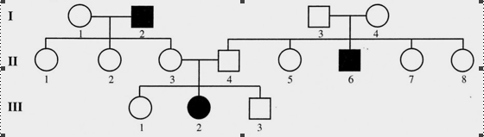

(a) Determine if the condition is dominant or recessive. Explain your answer. (1 mark)
(You may like to circle the part of the pedigree you are considering in your answer.)

_________________________________________________________________________________
____________________________________________________________________________
____________________________________________________________________________

(b) Determine the genotypes of the individuals in the pedigree. (Remember to work from
the bottom up.) (3 marks)
Write the genotypes for the following individuals.
Generation III Individual 1 ________
2 ________
Generation II Individual 3 ________
4 ________
Generation I Individual 1 ________
2 ________
20. The gene for a long nose (N) is dominant over the gene for a short nose (n).

(a) What genotypes could a long-nosed person have?

_____________________________________________________
(1 mark)
(b) What genotypes could a short-nosed person have?

_______________________________________________________________
(1 mark)

(c) If a long-nosed person with genotype NN has children with a person who has a short nose, what types of nose could their children have? Show reasons.
(3 marks)
___________________________________________________________________________________________________________________________________________________________________________________________________________________________________________________

21. Explain why mutations can be helpful to a species.

(2 marks)

22. Suggest two reasons why you would expect to find many well-preserved fossils in Antarctica.

(2 marks)

23. Look at the bar chart.

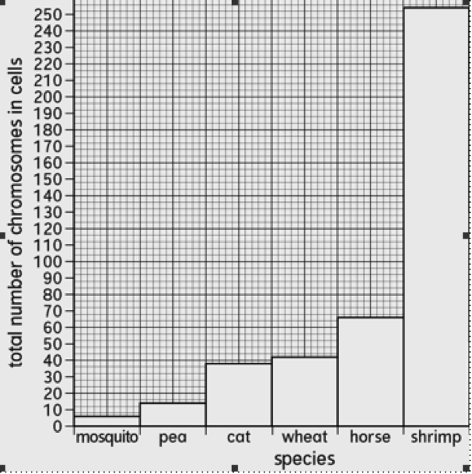

(a) How many chromosomes does a body cell in a cat have? (1 mark)

(b) Which species has 66 chromosomes in its cells? (1 mark)

(c) How many chromosomes are present in the body cells of humans? (1 mark)

(d) Why do you think that the total number of chromosomes in the cells of each species is an even number? (1 mark)

(e) Do you think there is a relationship (pattern) between the number of chromosomes in the cells and the size of the organism? (1 mark)

(f) Explain how you worked out your answer to part e.

______________________________________________________________________________
(2 marks)

